EXPERIMENT 3

ROLL NUMBER: 240701262 NAME: KEVINBHARATH.P

PYTHON CODE:

import tkinter as tk
from tkinter import ttk, messagebox

def convert():
try:
value = float(entry_value.get())
category = combo_category.get()
conversion = combo_conversion.get()

if category == "Length":
if conversion == "Kilometer to Meter":
result = value * 1000
output_label.config(text=f"Result: {result} meters")

elif conversion == "Meter to Kilometer":
result = value / 1000
output_label.config(text=f"Result: {result} kilometers")

elif category == "Mass":
if conversion == "Kilogram to Gram":
result = value * 1000
output_label.config(text=f"Result: {result} grams")

elif conversion == "Gram to Kilogram":
result = value / 1000
output_label.config(text=f"Result: {result} kilograms")

elif category == "Temperature":
if conversion == "Celsius to Fahrenheit":
result = (value * 9/5) + 32
output_label.config(text=f"Result: {result} °F")

elif conversion == "Fahrenheit to Celsius":
result = (value - 32) * 5/9
output_label.config(text=f"Result: {result} °C")

else:
messagebox.showerror("Error", "Invalid selection!")

except ValueError:
messagebox.showerror("Error", "Please enter a valid number!")

def update_options(event):
category = combo_category.get()

if category == "Length":
combo_conversion['values'] = (
"Kilometer to Meter",
"Meter to Kilometer"
)

elif category == "Mass":
combo_conversion['values'] = (
"Kilogram to Gram",
"Gram to Kilogram"
)

elif category == "Temperature":
combo_conversion['values'] = (
"Celsius to Fahrenheit",
"Fahrenheit to Celsius"
)

combo_conversion.current(0)

# Create main window
root = tk.Tk()
root.title("Unit Converter System")
root.geometry("400x300")
root.resizable(False, False)

# Title
tk.Label(
root,
text="UNIT CONVERTER SYSTEM",
font=("Arial", 14, "bold")
).pack(pady=10)

# Input value
tk.Label(root, text="Enter Value:").pack()

entry_value = tk.Entry(root, width=20)
entry_value.pack(pady=5)

# Category selection
tk.Label(root, text="Select Category:").pack()

combo_category = ttk.Combobox(
root,
state="readonly",
values=("Length", "Mass", "Temperature")
)
combo_category.pack(pady=5)

combo_category.bind("<<ComboboxSelected>>", update_options)

# Conversion selection
tk.Label(root, text="Select Conversion:").pack()

combo_conversion = ttk.Combobox(root, state="readonly")
combo_conversion.pack(pady=5)

# Convert button
tk.Button(
root,
text="Convert",
command=convert,
bg="green",
fg="white"
).pack(pady=10)

# Output label
output_label = tk.Label(
root,
text="Result: ",
font=("Arial", 12)
)
output_label.pack(pady=10)

# Run program
root.mainloop()

convert() Function — Main Logic
def convert():
This function runs when the Convert button is clicked.

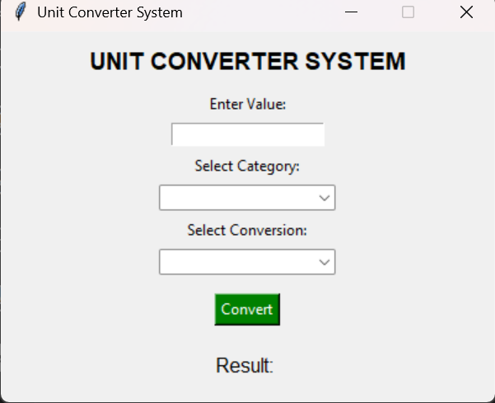

Step 1: Read User Input
value = float(entry_value.get())
- Gets number entered by user
- Converts text → float number
If the user enters invalid data → error handled using:
except ValueError:

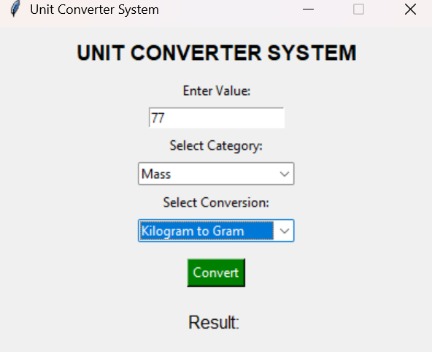

Step 2: Get Selected Options
category = combo_category.get()
conversion = combo_conversion.get()
Example:
- Category → Length
- Conversion → Kilometer to Meter

Unit Converter System — Explanation
This program creates a GUI (Graphical User Interface) using Python’s Tkinter library.
It allows the user to:
- Enter a number
- Select a unit category
- Choose a conversion type
- Click Convert
- View the converted result

Program Structure
The program has 3 main parts:
- Import libraries
- Functions (logic)
- GUI design

Import Libraries
import tkinter as tk
from tkinter import ttk, messagebox
✔ tkinter
Used to create windows, buttons, labels, etc.
✔ ttk
Provides styled widgets like Combobox.
✔ messagebox
Displays popup error messages.

GUI Creation (Window Design)

Main Window
root = tk.Tk()
Creates application window.
root.title("Unit Converter System")
root.geometry("400x300")
Sets title and size.

Title Label
tk.Label(root,text="UNIT CONVERTER SYSTEM")
Displays heading.

Input Field
entry_value = tk.Entry(root)
User types value here.

Category Combobox
combo_category = ttk.Combobox(...)
Options:
- Length
- Mass
- Temperature
Event binding:
combo_category.bind("<<ComboboxSelected>>", update_options)
👉 Automatically updates conversion choices.

Conversion Combobox
combo_conversion = ttk.Combobox(...)
Shows conversions based on category.

Convert Button
tk.Button(command=convert)
When clicked:
👉 Calls convert() function.

Output Label
output_label = tk.Label(...)
Displays result.

Start Application
root.mainloop()
Runs the GUI event loop continuously.

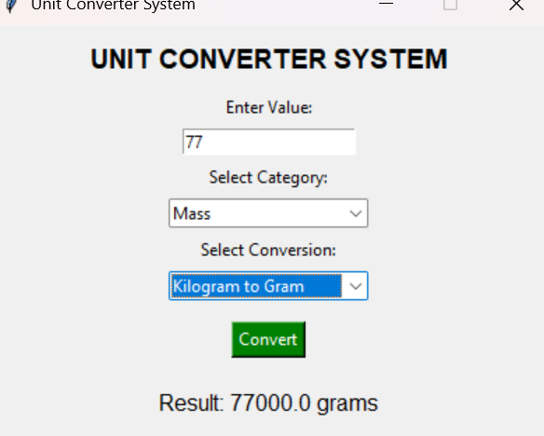Program Working Flow
Start Program
↓
Window Opens
↓
User enters value
↓
Select Category
↓
Conversion options update
↓
Click Convert
↓
Calculation happens
↓
Result displayed

Example Execution
Input:
Value = 5
Category = Length
Conversion = Kilometer to Meter
Output:
Result: 5000 meters

Features of Your Program
✔ User-friendly GUI
✔ Dynamic dropdown options
✔ Error handling
✔ Multiple unit categories
✔ Real-time result display

Possible Improvements (Optional)
You can enhance by adding:
- Time conversion
- Area conversion
- Currency converter
- Clear button
- Dark theme
- Auto result update

